Space & Time Final Project

Joseph Fatzinger

HIST 2890

12/04/2017

**French Conquer Algiers**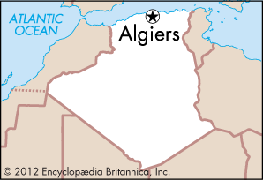

* **Space:** Algiers
* **Time:** 1830
* **Who:** Barbary Corsairs
* **Relationship Between Time & Space:** Corsairs at Algiers in 1830 received support from the State. This ended after the Battle of Algiers

**Francis Drake’s Expedition of the World**

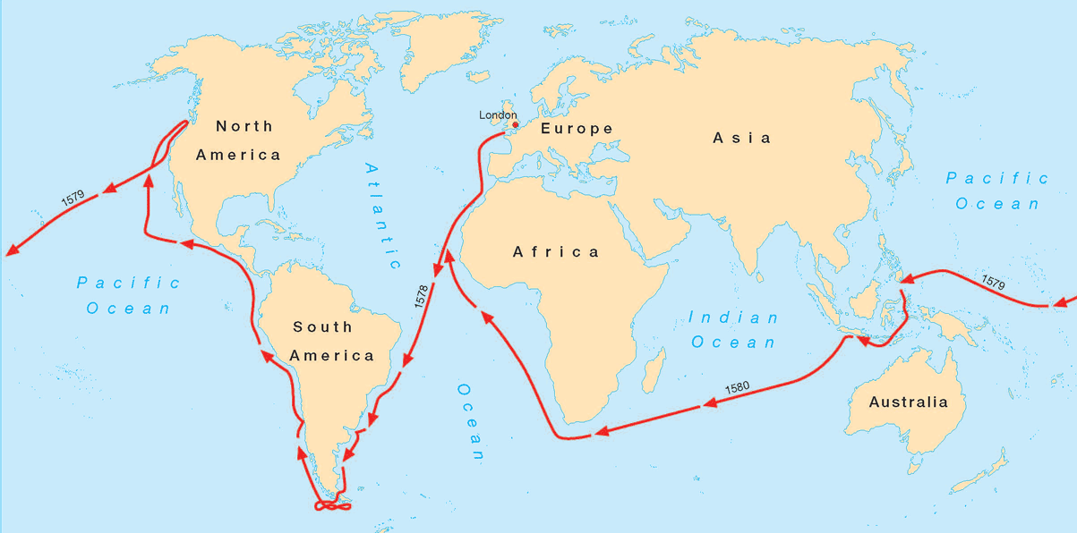

* **Space:** Started and ended in Britain
* **Time:** 1577-1580
* **Who:** Sir Francis Drake
* **Relationship Between Time & Space:** England at this time unofficially supported Francis Drake to travel and plunder around the world.

**Henry Morgan Raiding the Spanish**

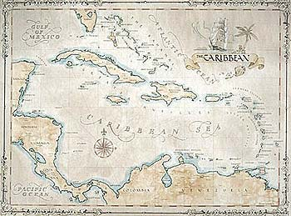

* **Space:** The Caribbean’s
* **Time:** 1664-1669
* **Who:** Henry Morgan
* **Relationship Between Time & Space:** During this period the British unofficially supported Henry Morgan’s raids on the Spanish colonies in the Caribbean’s and the Americas

**The British War on Pirates**

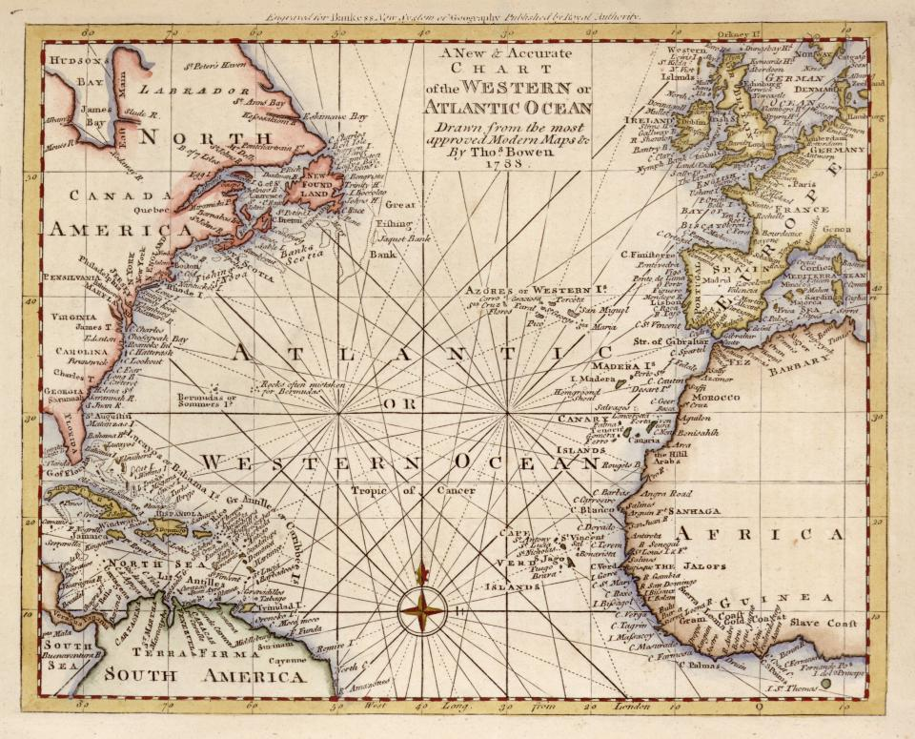

* **Space:** Oceans and British Territories
* **Time:** 1715-1730
* **Who:** British & Golden Age Pirates
* **Relationship Between Time & Space:** Marked the end of Britain’s tolerance for piracy and showed the determination of British to end piracy on the oceans.

**Bai Ling Vs. Banner Fleets**

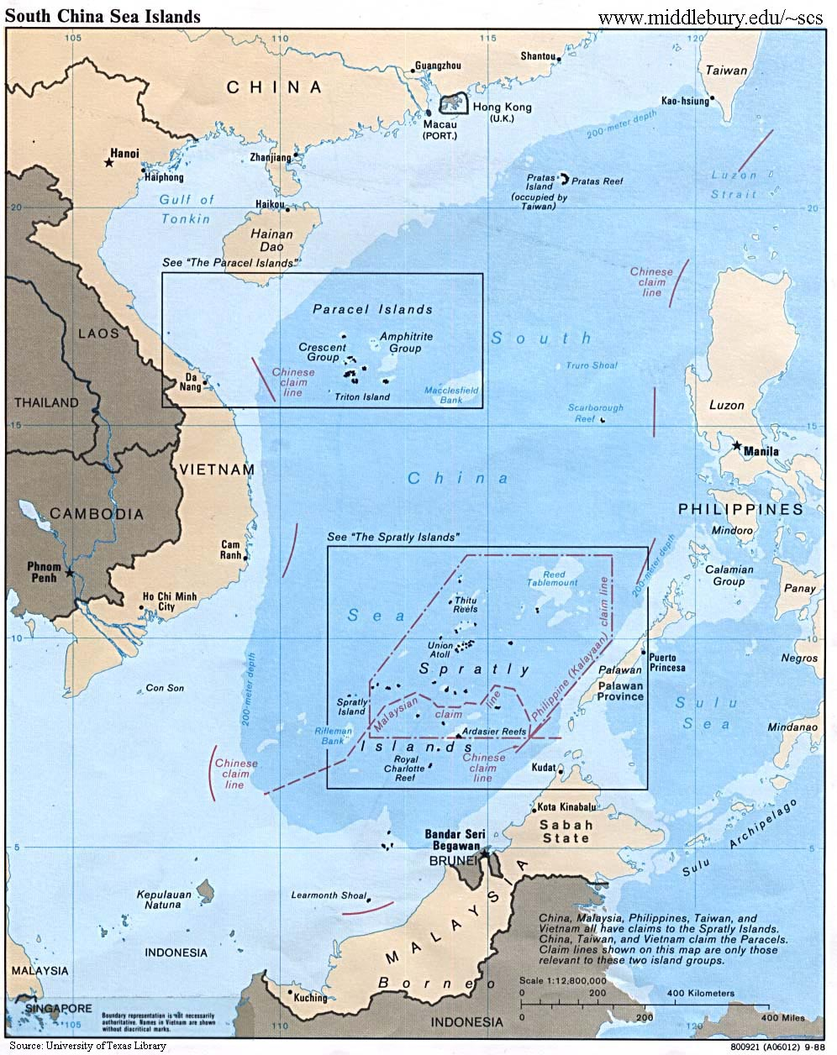

* **Space:** South China Sea
* **Time:** 1810
* **Who:** Bai Ling
* **Relationship Between Time & Space:** In China during this period, large pirate gangs were an immense problem. In 1810 Bai Ling successfully put a stop to the Banner Fleets power in the South China Sea.

**Ruling by Lord Mansfield**

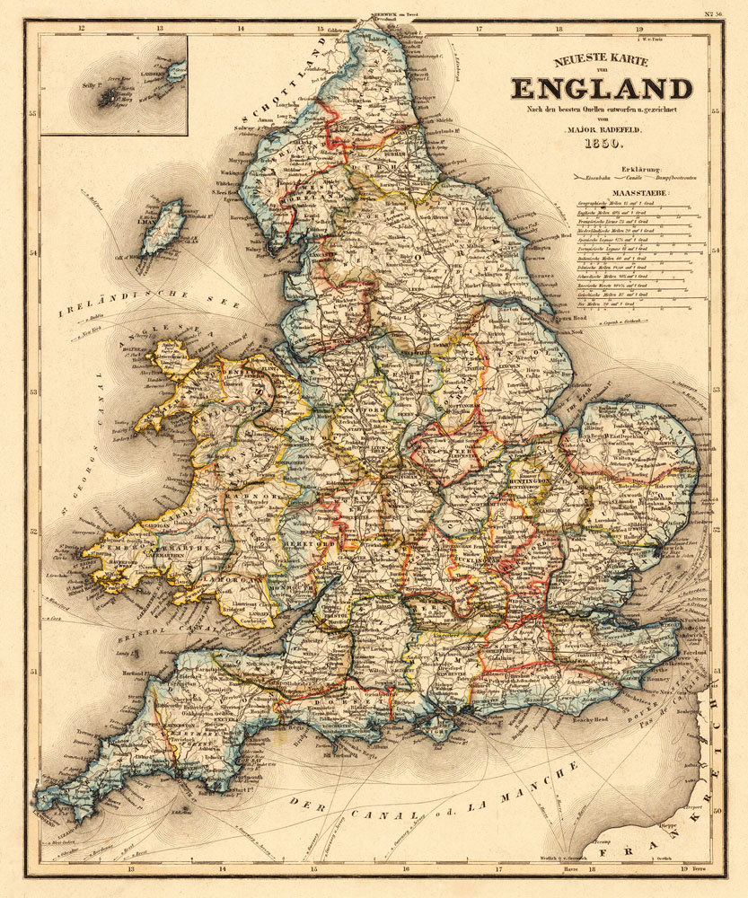

* **Space:** England (affected coastline)
* **Time:** 1771
* **Who:** Wreckers
* **Relationship Between Time & Space:** This Law implemented the death penalty for wreckers who kept any items from wrecks. Wrecking at this time was a lifestyle for many poor people on the coastline of England.

**Lin Zexu vs. Smugglers**

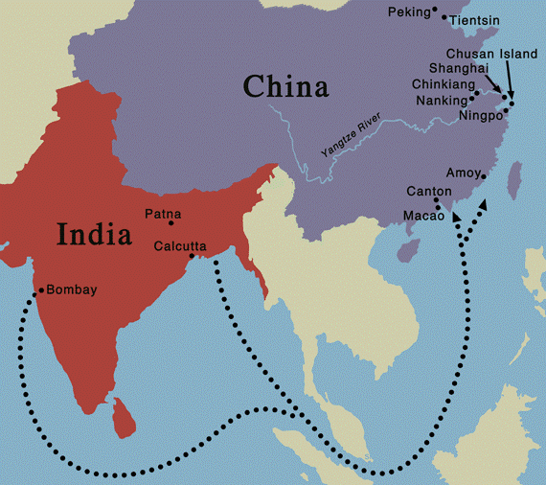

* **Space:** China
* **Time:** 1839
* **Who:** British and China Merchants
* **Relationship Between Time & Space:**

China was suffering from a vast opium epidemic, that came from England who was using India to smuggle in the opium, throughout this period. This led to the Opium Wars.

**The Doctors’ Riot**

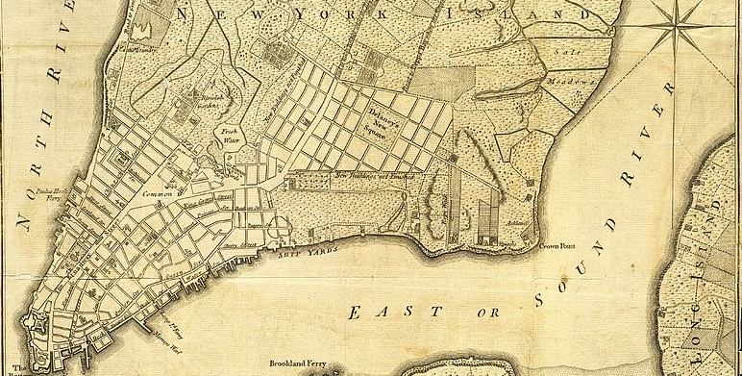

* **Space:** New York
* **Time:** 1788
* **Who:** Citizens of New York
* **Relationship Between Time & Space:**

This Riot showed how people reacted to do body-snatchers in this time. Led to laws being created to stop body-snatching in New York.

**The Maiden Tribute of Modern Babylon**

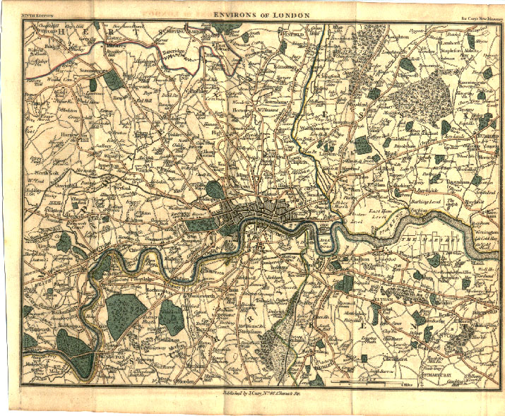

* **Space:** London
* **Time:** 1885
* **Who:** Published in the Pall Mall Gazette and concerning child prostitution
* **Relationship Between Time & Space:**

This article brought attention to the illegal prostitution happening in the underworld of London in the 19th century.

**Lynching of the Reno Gang**

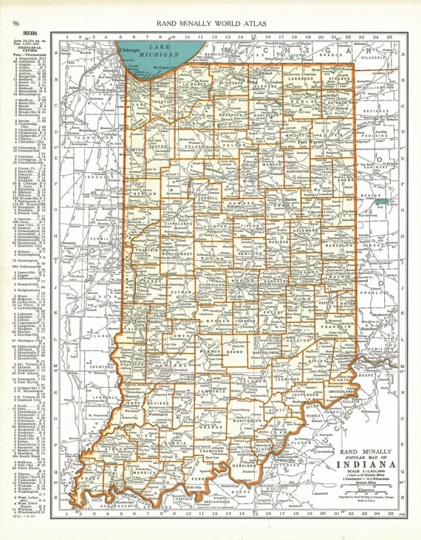

* **Space:** Indiana
* **Time:** 1868
* **Who:** The Reno Gang and The Seymour Vigilance Committee
* **Relationship Between Time & Space:** At this time, Indiana was faced with the burden of train robbers. Vigilantes took the law into their own hands to enforce justice.

**Marine Broadcasting Offences Act 1967**

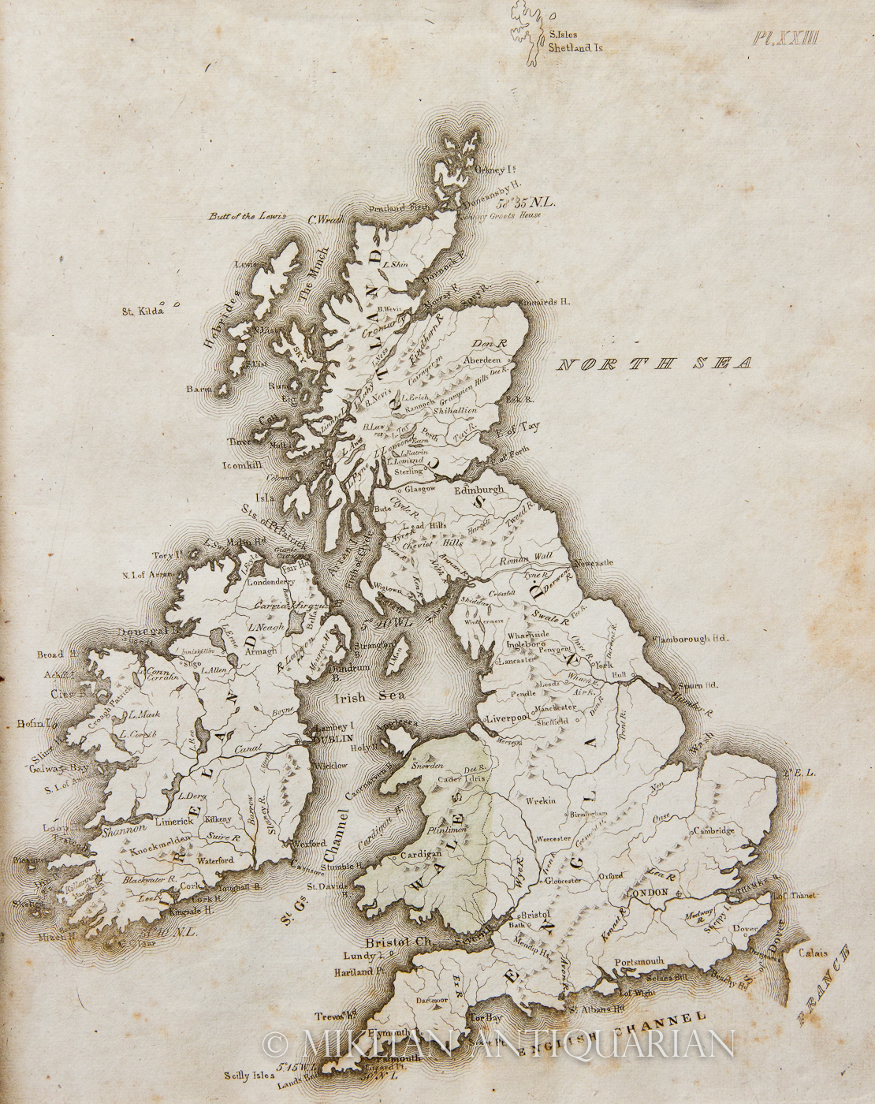

* **Space:** England and nearby waters
* **Time:** 1967
* **Who:** Parliament and Radio Pirates
* **Relationship Between Time & Space:** During this period English Parliament restricted radio uses, therefore radio pirates acted on international water to broadcast rock and roll music.